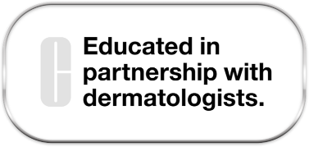
Raise your Sun Standards Notes
- What claims do all UV Solutions share?

- What skincare benefit do all UV Solutions share?

- UV Solutions Mattifying Sunscreen SPF 50:
Key benefits:
Key ingredient:
Key claims:
- UV Solutions Hydrating Sunscreen SPF 50:
Key benefits:
Key ingredient:
Key claims:
- UV Solutions Brightening + Tinted Sunscreen SPF 50:
Key benefits:
Key ingredient:
Key claims:
- UVROSOxidative StressAgingDNA/Damage
What is ROS?
What damage does ROS cause?
How long does the damage continue?

- How do antioxidants work together in sunscreen to protect the skin from environmental damage?
Lychee Seed Extract
Vitamin E
Provitamin D
Rice Bran Extract
- What types of skin damage are caused by UVA and UVB radiation?
UVA rays
UVB rays
- How will you utilize these Clinique Engagement tools?
UV Index
Clinique Clinical Reality Hidden Damage
Quick Guide to Great Skin
- What’s the difference between mineral and chemical sunscreen?
Mineral
Chemical

